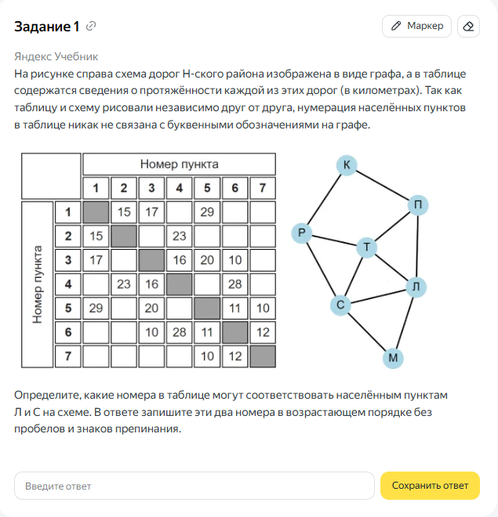



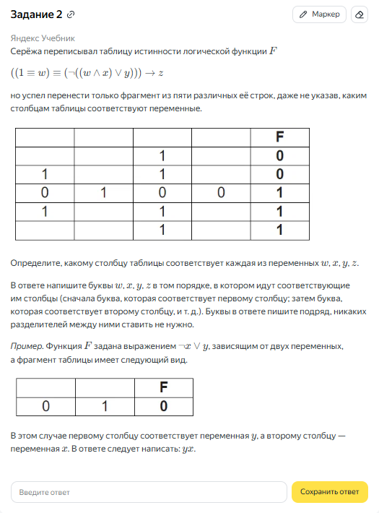





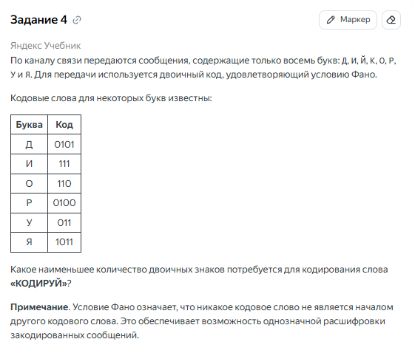



|  |  |  |  |  |
| --- | --- | --- | --- | --- |
|  | **Буква** | **Код** | **Кол-во** |  |
|  | Д | 0101 | 1 | 4 |
|  | И | 111 | 1 | 3 |
|  | О | 110 | 1 | 3 |
|  | Р | 0100 | 1 | 4 |
|  | У | 011 | 1 | 3 |
|  | Я | 1011 | 0 | 0 |
|  | К |  | 1 |  |
|  | Й |  | 1 |  |
|  |  |  |  |  |

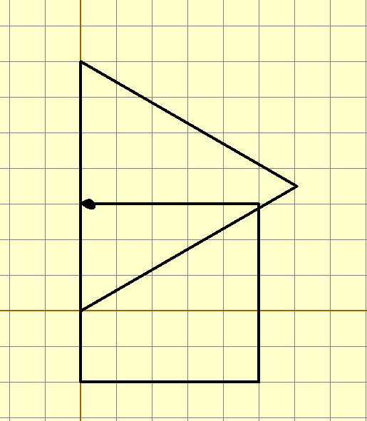



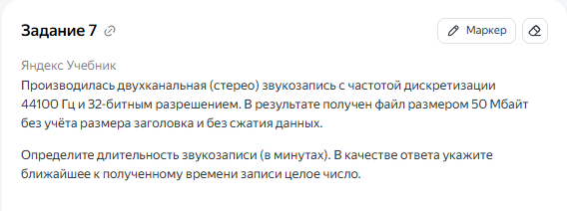



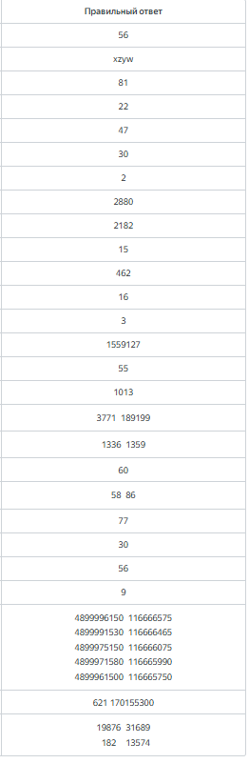



29 – 14 = 15

